Contents

Analyze resource utilization and consumption 2

Types of Platform Logs 2

Resource Logs 2

Activity logs: 2

Azure Active Directory Log: 2

Azure Monitor 2

Azure Invoices 2

Azure Site Recovery 3

Azure File Recovery 4

# Analyze resource utilization and consumption

## Types of Platform Logs

# Resource Logs

# Activity logs:

<https://docs.microsoft.com/en-us/azure/governance/management-groups/overview#audit-management-groups-using-activity-logs>

These logs are kept for 90 days if stored for more than that then it is charged

https://docs.microsoft.com/en-us/azure/azure-resource-manager/management/view-activity-logs

# Azure Active Directory Log:

# Azure Monitor

It was also called Operations Manager Suite (OMS)

Azure Monitor will replace Log Analytics in future

# Azure Invoices

<https://docs.microsoft.com/en-us/azure/cost-management-billing/understand/download-azure-invoice>

[Activity log](https://docs.microsoft.com/en-us/azure/azure-monitor/platform/activity-log)

<https://docs.microsoft.com/en-us/azure/governance/management-groups/overview#audit-management-groups-using-activity-logs>

These logs are kept for 90 days if stored for more then it is charged

[Azure Active Directory logs](https://docs.microsoft.com/en-us/azure/active-directory/reports-monitoring/overview-reports)

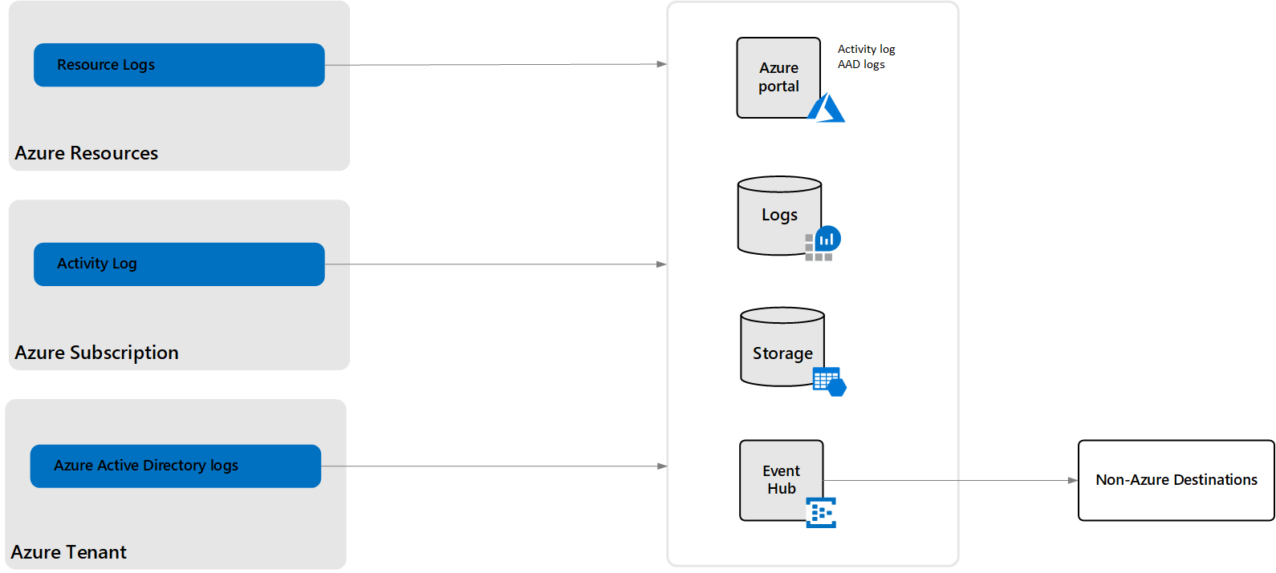

# Azure Migrate

This is agentless service.

<https://www.youtube.com/watch?v=0s2ZqHgieT0>

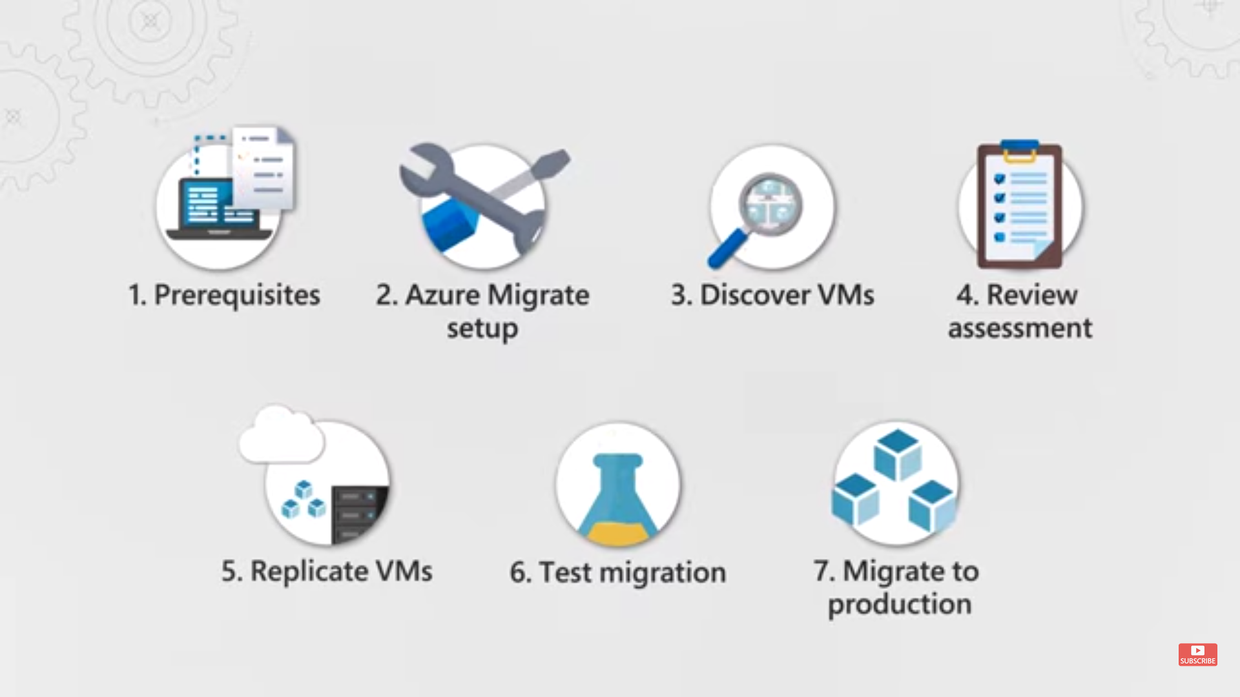

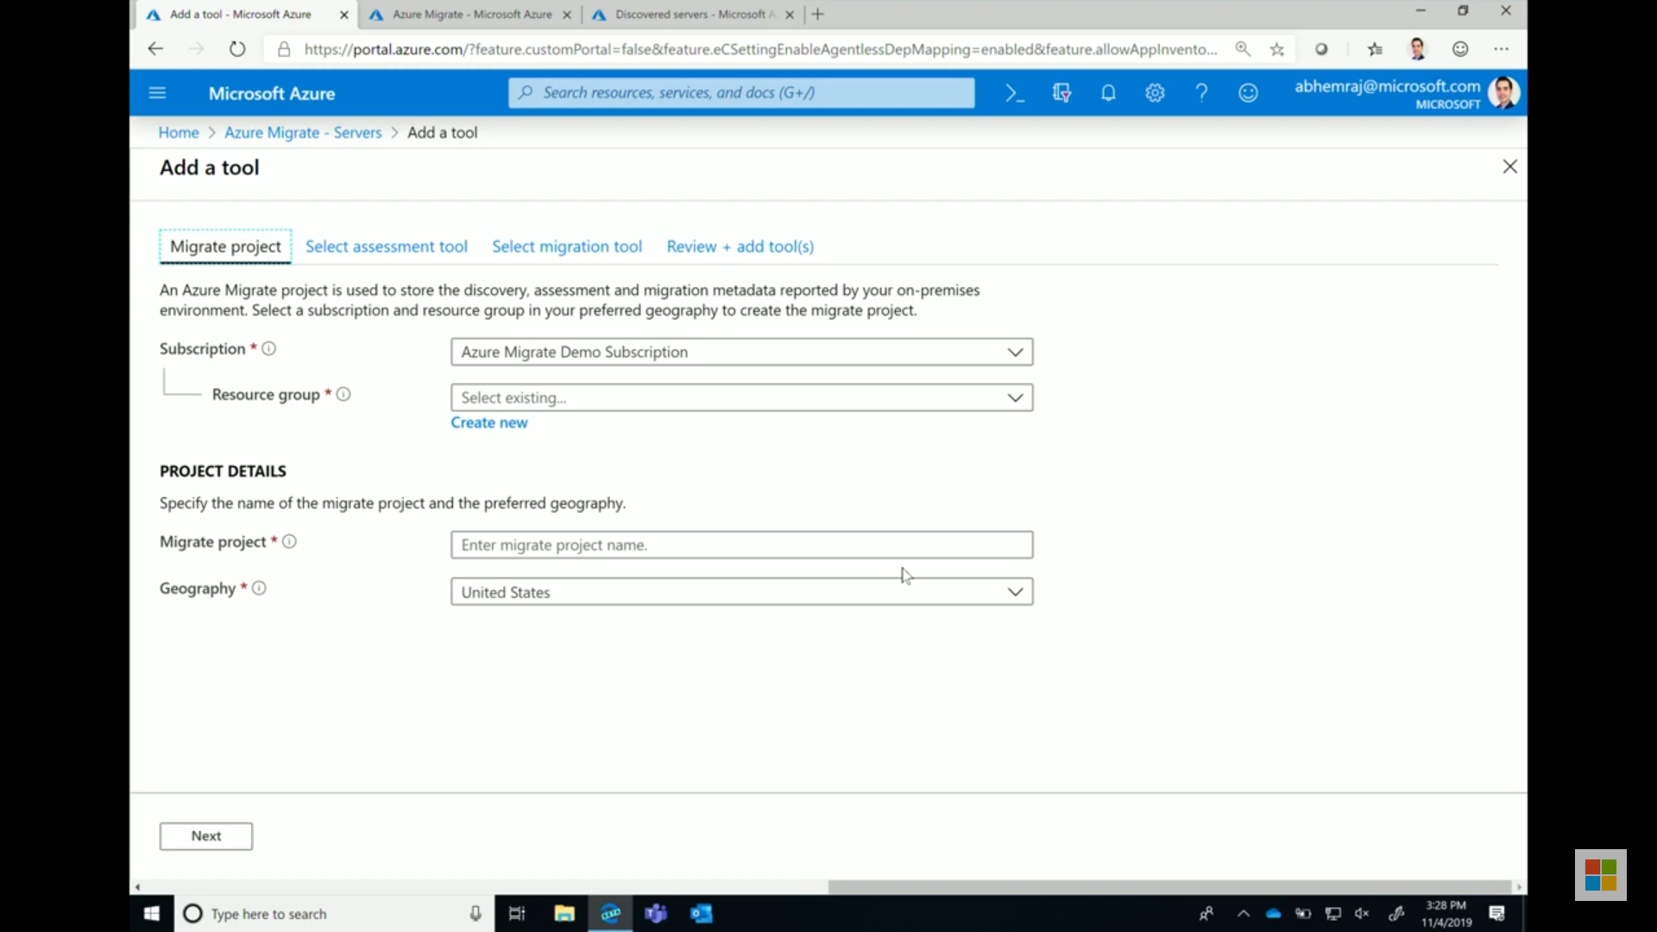

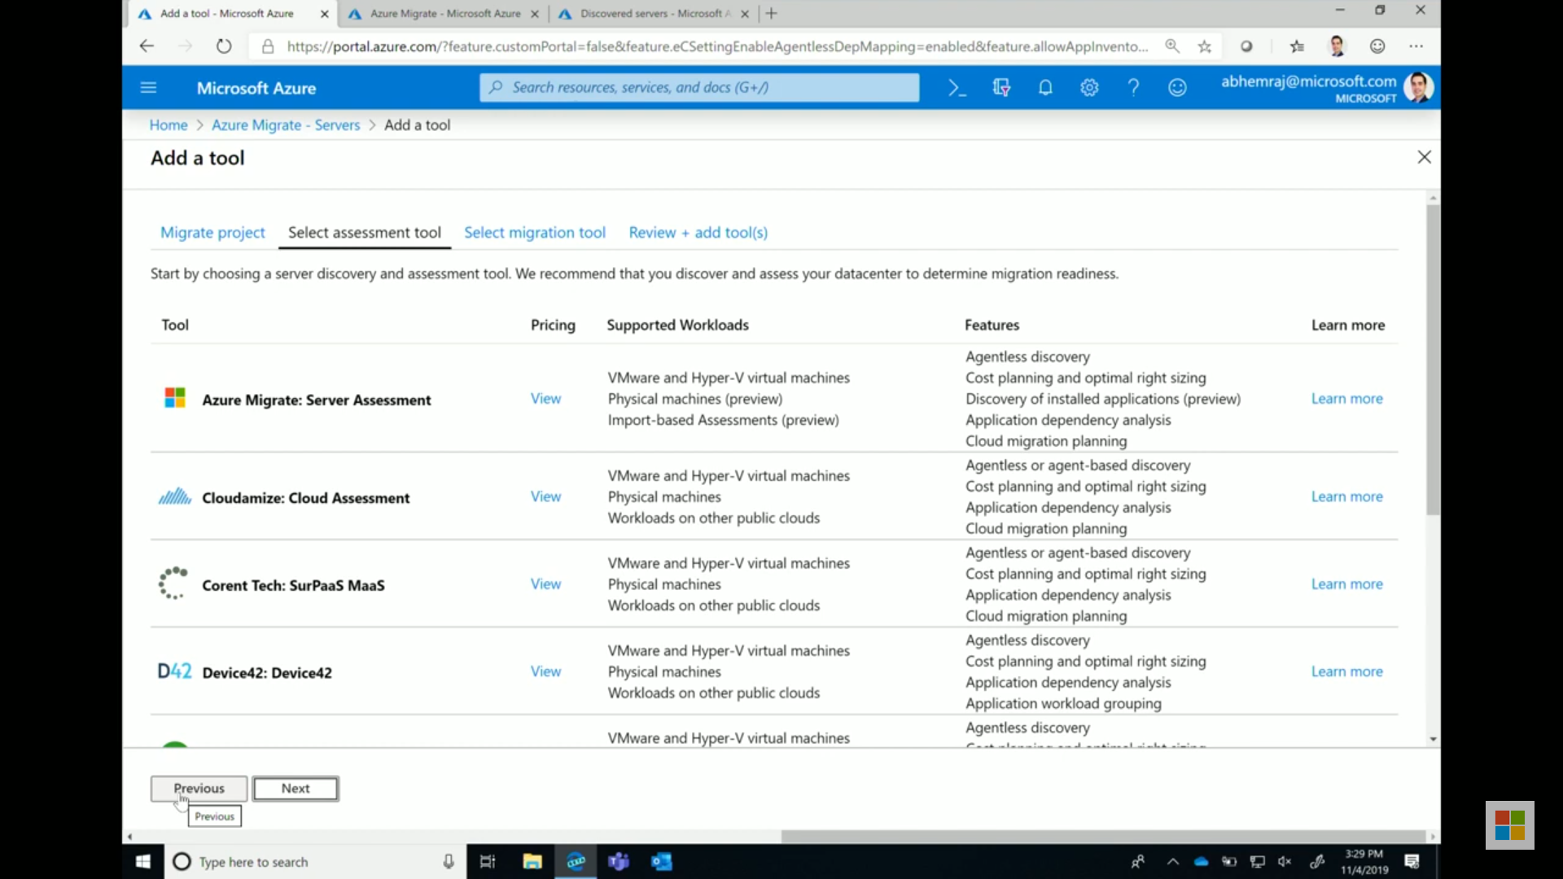

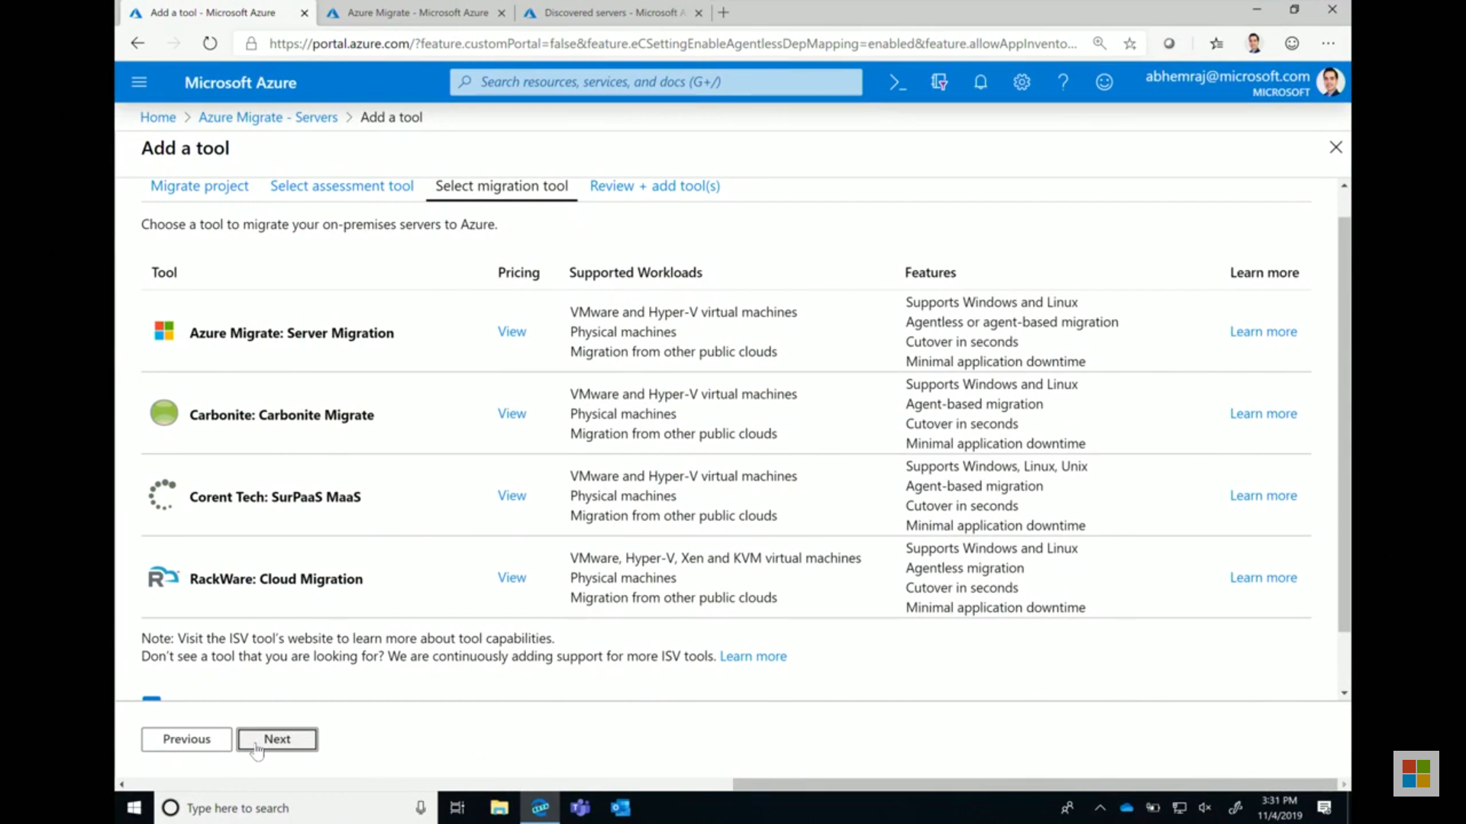

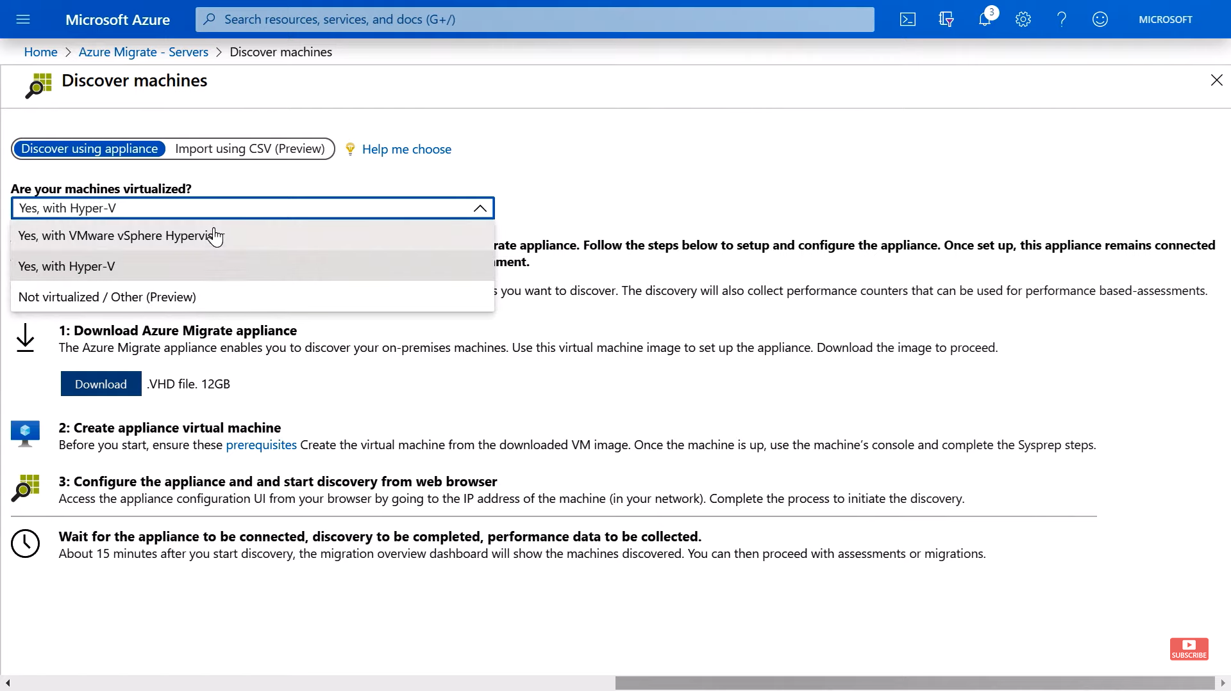

After this step import Azure Migrate Appliance in your VMSphere and it will not install any agent there but gather meta information from VM Sphere and prepare the report after discovering.

It will ask for Azure migrate credential and vCenter Server credential.

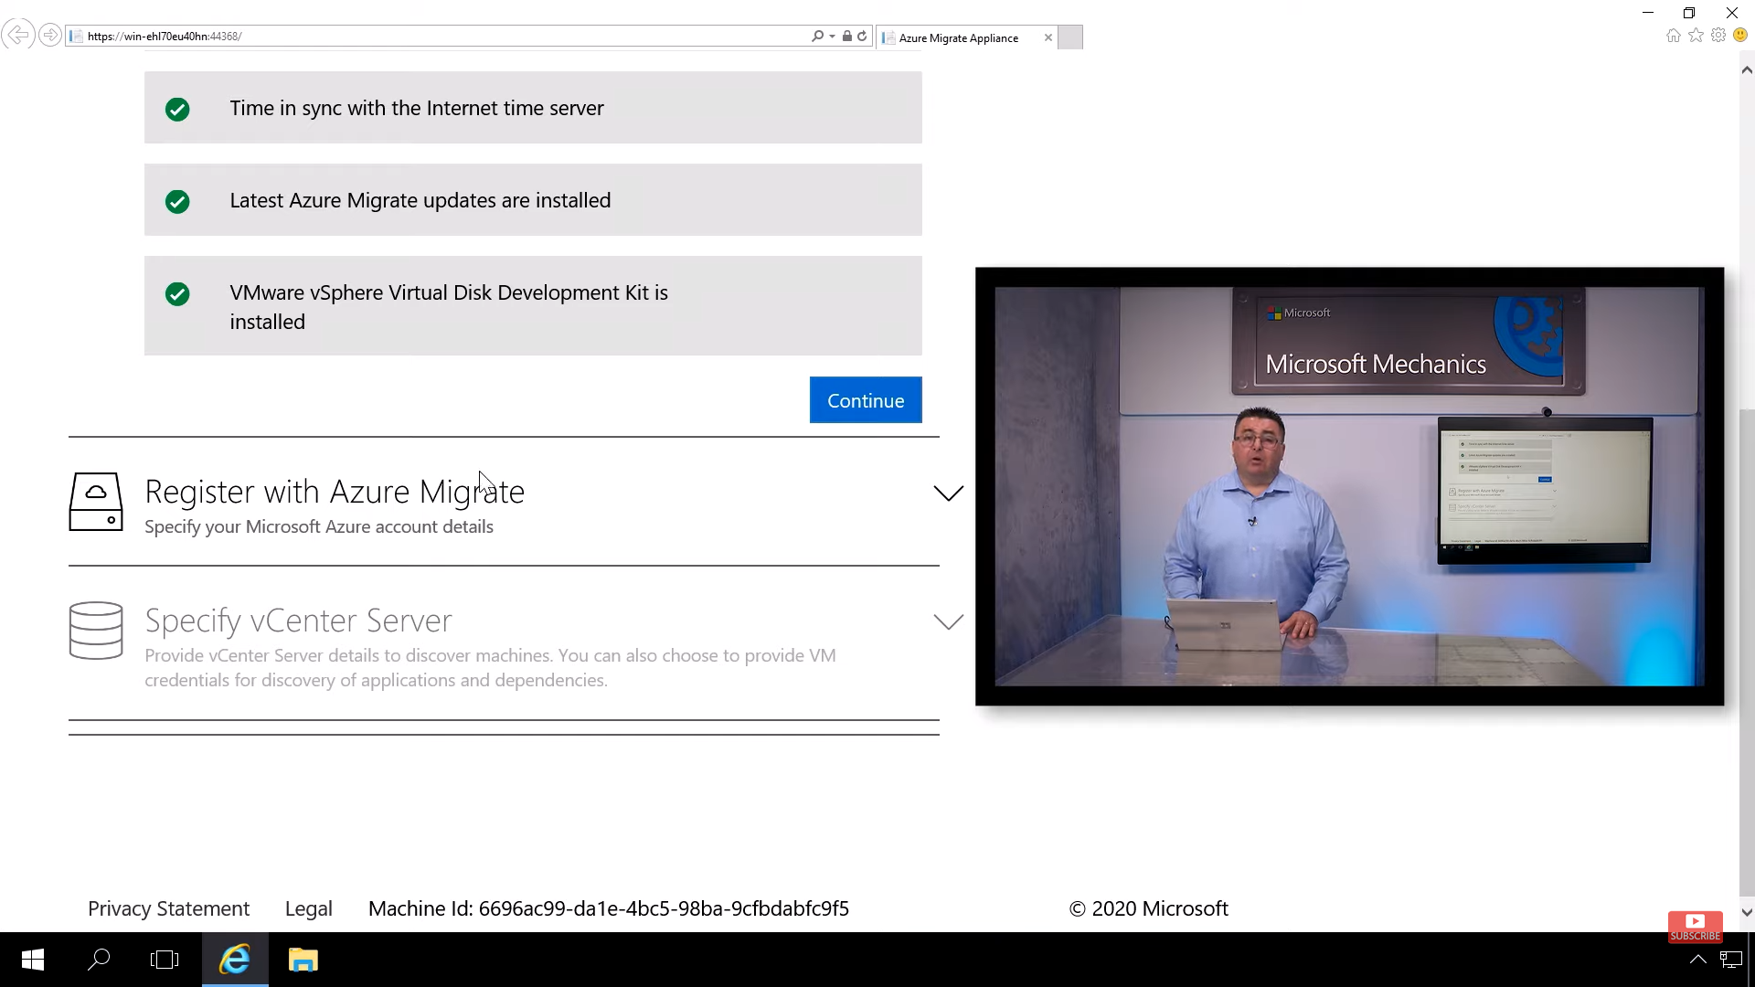

It will then do assessment and start sending information to Azure Migrate. Where you can click Assess option in assessment tools tab to group the list of machines you want to assess and later use the same assessment group in migrate option.

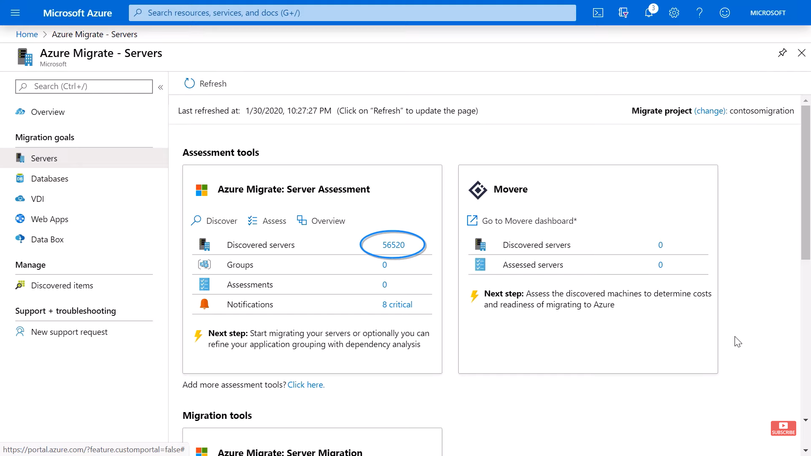

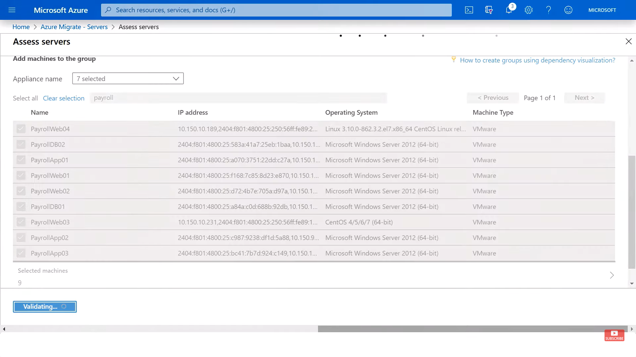

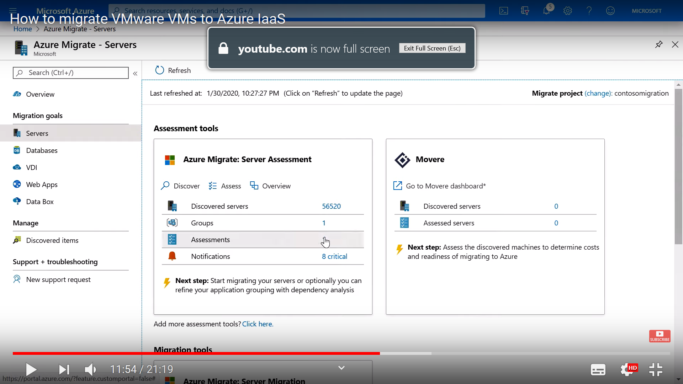

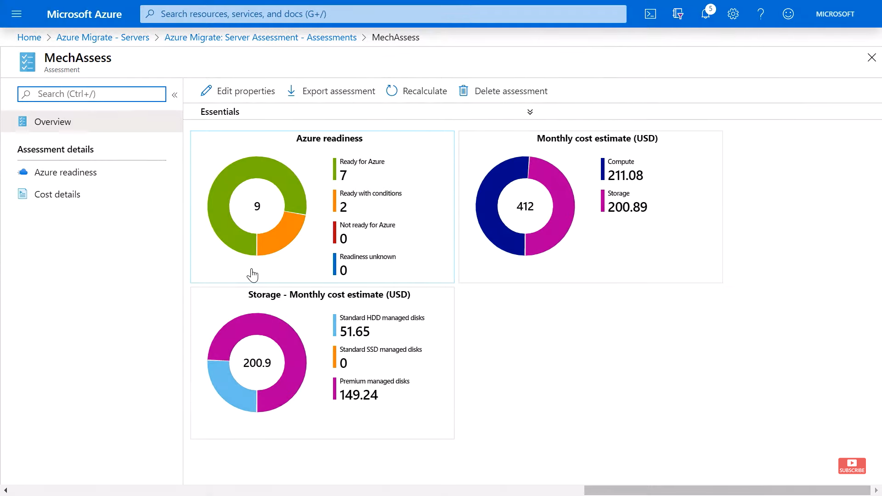

Before migration for windows system ensure **SAN Policy=OnlineAll**

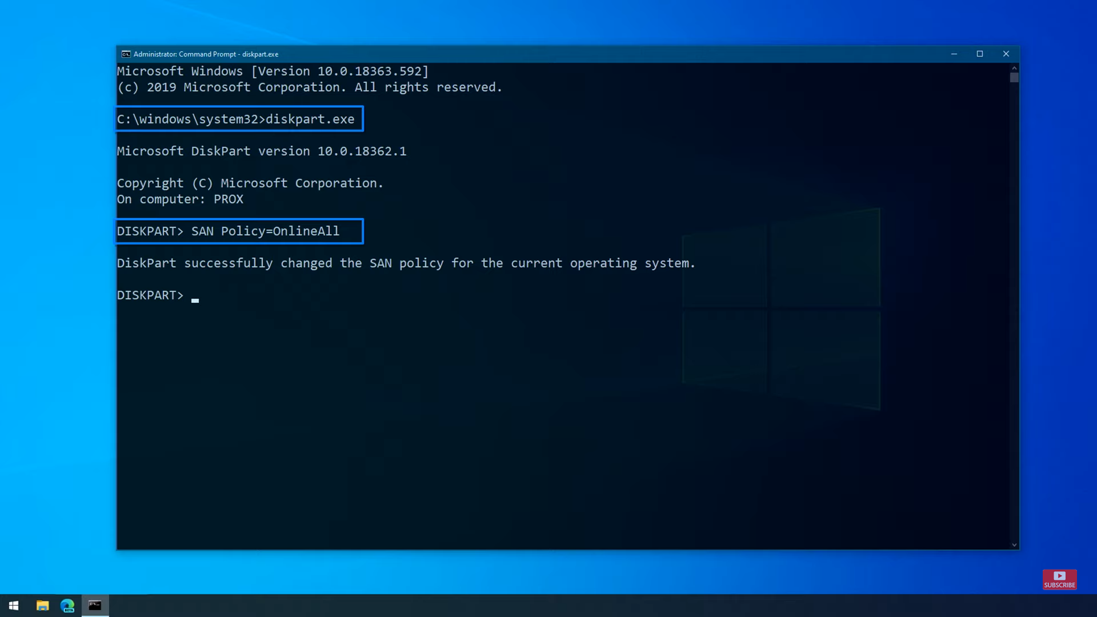

After this go to migration tool and follow the following steps:

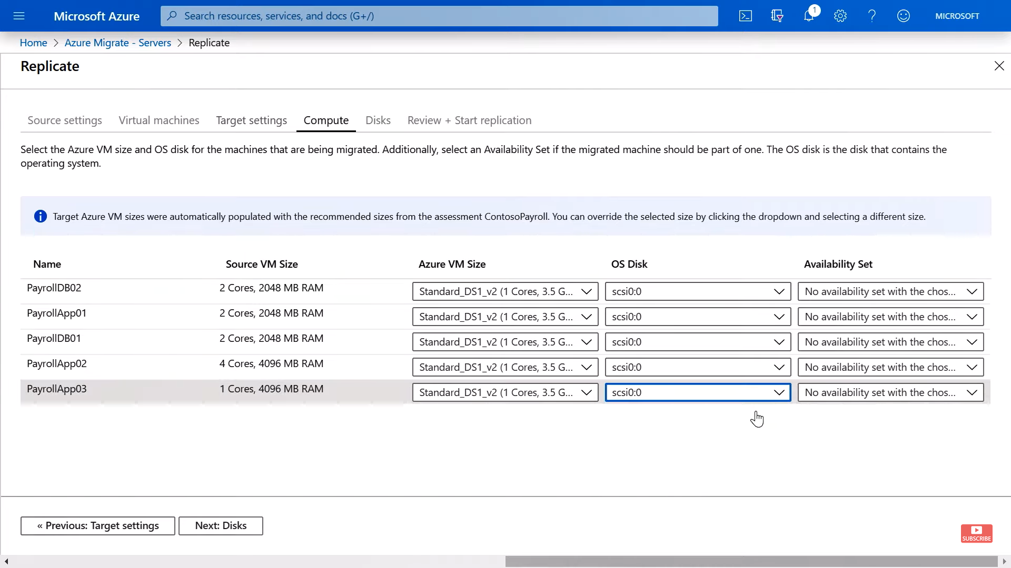

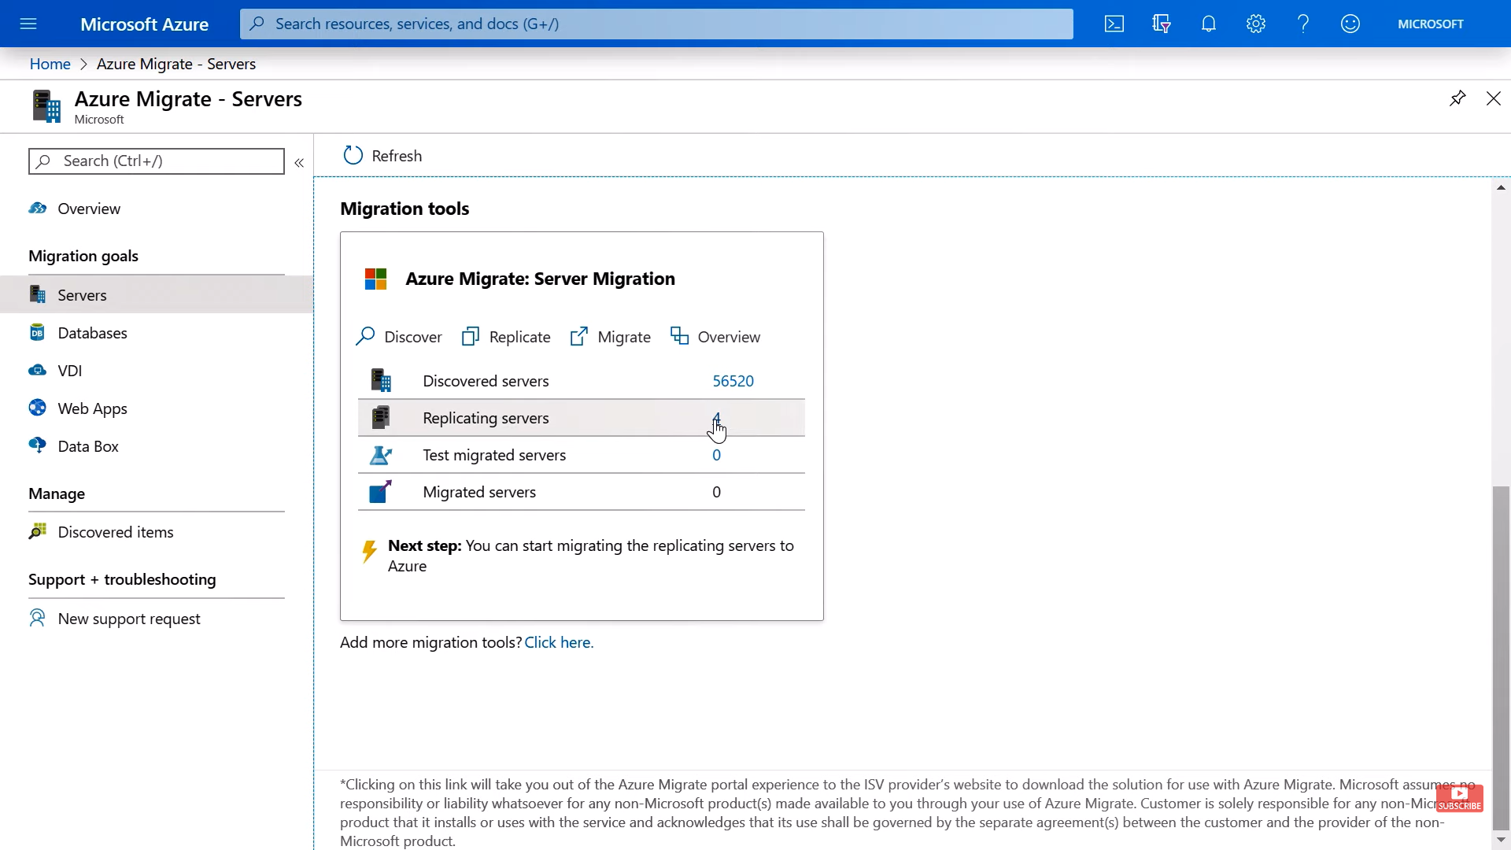

And then we can test the replicating machines. A postfix “-test” will get appened to each machine name and one test it working there once statisfied we can “clean up test migration” and use the “migrate” option to move to next stage.

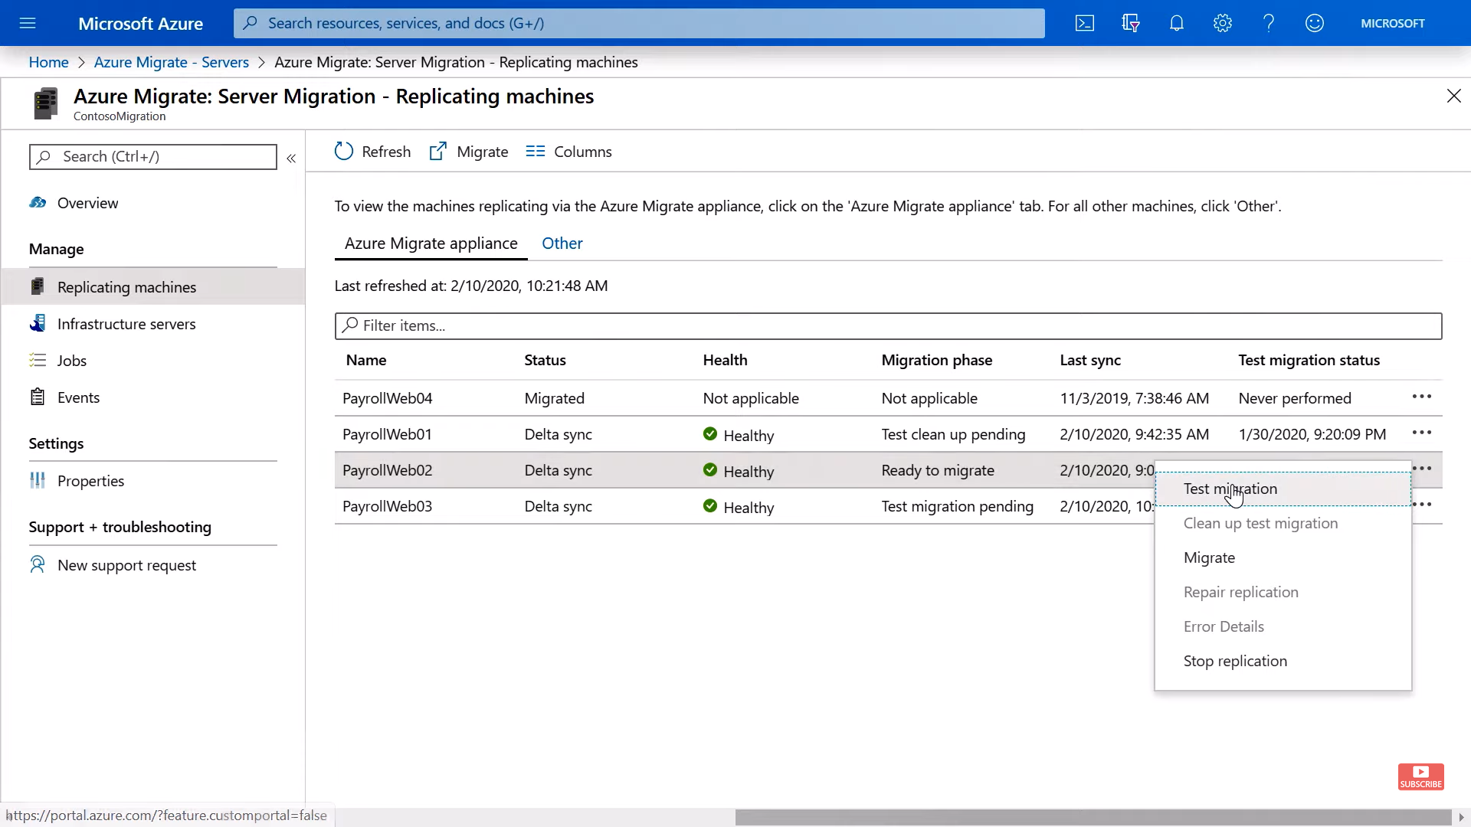

There are various options we can choose while migrating, for example we can use VMware tools and that will use Azure VMware Solutions to replicate our environment.

Or one can user server migration to migrate both web and DB server.

Or we can ser server migration to migrate server and DB migration to migrate DB to Azure SQL

Or even user Web App Migration to migrate Web Apps to App Service.

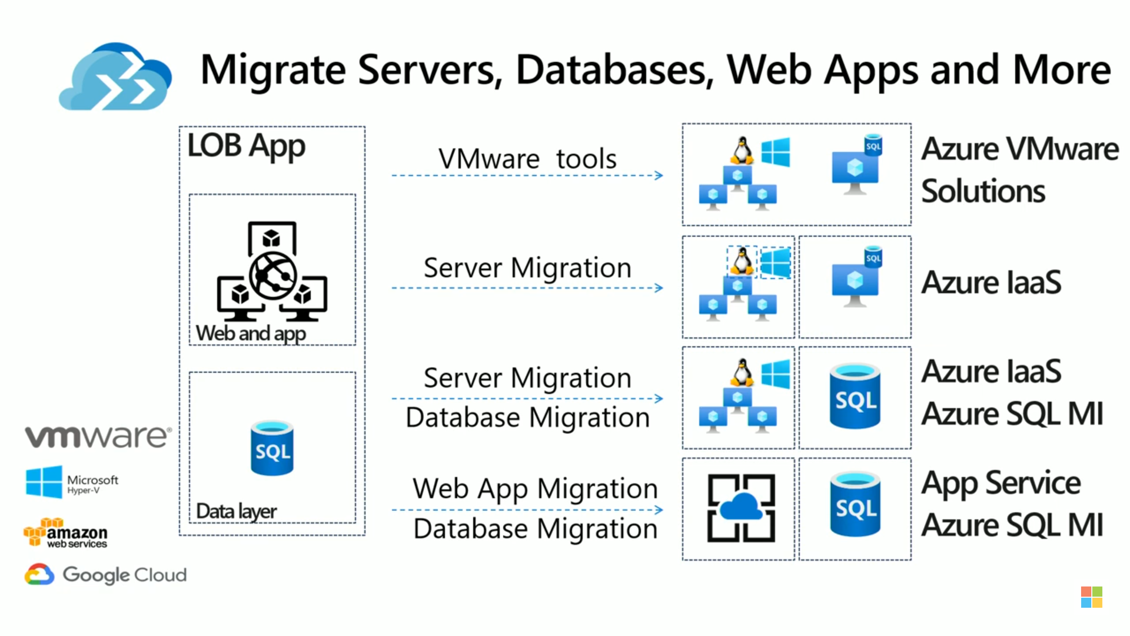

<https://docs.microsoft.com/en-us/azure/cloud-adoption-framework/>

# Azure Site Recovery

<https://docs.microsoft.com/en-us/azure/site-recovery/site-recovery-overview>

This is a DR tool and can be used for migration.

<https://docs.microsoft.com/en-us/azure/site-recovery/migrate-tutorial-on-premises-azure>

The correct steps are as follows: Create a recovery services vault. Select a replication goal. Set up the source and target environment. Setup a replication policy. Enable replication. Run a migration test. Run a onetime failover to Azure.

the recovery service vault has to be in the same region as the virtual machines.

<https://docs.microsoft.com/bs-cyrl-ba/azure/backup/backup-create-rs-vault>

# Azure File Recovery

<https://azure.microsoft.com/en-us/blog/instant-file-recovery-from-cloud-backups-using-azure-backup/>